Article

Design and implementation of virtual coaches for healthy nutrition habits monitoring and encouragement.

Academic Editor: University of Granada

Received: date; Accepted: date; Published: date

**Abstract:** Agood health is the result of a healthy lifestyle, where nutrition is a key concern. However, in today’s society, nutritional disorders affect children, adults and elderly people, mainly due to a scarce nutrition knowledge and the lack of a healthy lifestyle. A commonly adopted solution to these nutritional imbalances is to record food intake over the course of the day, usually, creating custom meal plans to count the amount of macronutrients and micronutrients acquired in each meal. Nowadays, there exist many nutritional tracking applications (NTA) that record energy intakes as well as users’ physiological parameters. However, most of these NTA are unsupervised applications. That is, they have not been designed to provide gradual meal plans that are tailored to the users and that help them to adopt healthy nutrition habits, or are not supervised by health professionals. In this manuscript, we present a system architecture intended to serve as a reference architecture for building NTA that include plans to adopt a healthy habit gradually in association with professional supervision guidelines. In order to show the applicability of the architecture presented, it is also introduced Food4Living, an app based on the proposed reference architecture and which consists of a cloud-based mobile wellness platform to support the monitoring of daily nutrition habits and improve them through the interaction between users and professional advisors (nutritionist and dieticians). The main benefit of Food4Living is the improvement of autonomy and independence of users through real-time feedback during the process of compliance with adapted diets, adopting new eating habits under rigorous expert control. Food4Living is especially targeted to older people, whose specific needs are not conveniently addressed in the state-of-the-art systems.

**Keywords:** nutrition; telemonitoring; usability; cloud computing; healthy habits; elderly people; smartphones; nutritional assessment; virtual coach;

1. Introduction

Healthy aging involves the interaction between genes, the environment, and lifestyle factors, particularly good eating habits and regular physical activity. Worldwide, the increase in life span has led to an increase in morbidity and mortality as the result of chronic, lifestyle-influenced diseases such as type 2 diabetes, cardiovascular disease and cancer, among others. Nutrient deficiency diseases are giving way to energy imbalances, so links between diet and chronic disease are becoming clearer [1]. Lack of healthy habits such as eating disorders and sedentary lifestyle are the main causes of health issues, according to the World Health Organization [2].

The food we eat is composed of two main groups of nutrients: (1) macronutrients (carbohydrates, proteins and fats), which contribute most of the metabolic energy to the organism; and (2) micronutrients (vitamins and minerals), which are necessary in small proportions and do not provide energy. To be healthy, it is essential to maintain a correct balance of macronutrients and micronutrients, and not exceed the amount that our body needs. A lack of control over nutritional requirements is the main cause of cardio-vascular diseases. This fact highlights the importance of accomplishing food plans that balance all body needs [3]. Adults may engage successfully in changing their eating habits with the aid of a professional nutritionist who performs a strict and continuous monitoring of the user through the design of specific and targeted meal plans and habits [4,5]. However, the elderly may experience difficulties for carrying out traditional food monitoring through regular visits to the nutritionist because of mobility issues and the difficulties to understand and carry out traditional monitoring methods [6,7].

Mobile devices constitute a useful tool to address these challenges. They have become a commonplace in healthcare settings, leading to rapid growth in the development of medical software applications for mobile platforms. Numerous apps are now available to assist health care professionals with many important tasks, such as: information and time management, health record maintenance and access, communications and consulting, reference and information gathering, patient management and monitoring, clinical decision-making, and medical education and training [8]. Currently, mobile applications designed for self-tracking of calories and macronutrients are mainly aimed at establishing general food plans for users, and, although it has been observed that they are helpful in promoting healthy habits, the lack of flexibility to establish a diet using the application usually is the main reasons to abandon its use [9].

Focusing on the problem at hand, often, elderly people, find it difficult to attain the benefits of the technological solutions currently available, as they do not serve as a simple and direct tool between the communication of users and nutritionists who supervise their nutritional habits, since these tools may not be intuitive to older adults. For example, frequently, these tools show more information than the user needs, and focus the functionalities of the available applications to a self-monitoring not supervised by nutritionists. However, although this is a step forward, it does not suffice to have a healthy lifestyle, mainly because these applications are used at the discretion of each user, and also, they are not experts in nutrition, even if they count the calories, they may maintain bad eating habits. Also, since nutrition interacts with other pathologies related to ageing, coordination of people and services together with meaningful guidance is essential.

Nonetheless, besides the provision of a particular functionality, this kind of technical solutions requires an underlying system architecture that supports developers in their construction first, and ultimately end-users (nutrition practitioners and supervised users) in the consumption of coordinated value-added services related to the acquisition of healthy nutrition habits.

In this paper we present a modular architecture that serves as a basis on of which to build telemonitoring and ecoaching nutrition platforms.

As a part of the contribution, and to validate the proposed architecture, we have developed the Food4Living Applications (Food4LivingAPP) to show how it can be used to easily develop nutrition coaching applications. System architecture and Food4Living applications have been produced in the context of an interdisciplinary research project called Avisame providing the desired flexibility to be easily combined with other fitness and wellness coaching platforms within the project.

This document is divided into four distinct sections. This first section has presented the motivation of the proposal, introducing the work described in this document as well as the objectives pursued in our project. The second section presents the development process, specifying the analysis, design and implementation of the architecture and the different applications. The third section shows the general discussion behind development. Finally, section fourth presents the conclusions and future work.

2. Related Work

Currently, there are numerous studies for healthy weight loss expose the effectiveness of new platforms for the nutritional telemonitoring of users [10,11]. These studies set out guidelines and keys to achieve a careful nutritional process [12]through the development of platforms or applications that satisfy the main branches in this process. These main branches are 1) the realization of nutritional evaluations, 2) nutritional diagnoses, 3) nutritional monitoring and evaluation, and 4) nutritional intervention. Based on these guidelines, we have designed our platform that implements each of the categories offering a scheme to develop applications that perform complete food records, remote monitoring of user progress, goal systems and nutritional education for users.

To design Food4Living we have studied different alternatives of other telemonitoring platforms to start with a proven scheme, and in the same way, analyze the deficiencies of those platforms in the area we seek to address [13-15]**.** These platforms expose architectures divided into different subsystems for the functionalities of the monitored users and the operational elements that analyze the data obtained by the previous subsystem. Its architecture is based on different layers and modules, which are responsible for isolating the graphical interfaces of the applications, with sub-modules that synchronize and operate the data in a central server where all data is consulted. Our proposal works in a similar way to the previously studied platforms, but adding other subsystems addressed to professionals (nutritionists) that elaborate new information for the monitored users.

To carry it out, telemonitoring platforms collect information on the behavior of supervised users and, from an analysis process, professionals draw conclusions about those supervised users. Our proposal changes the order of these interactions creating a cycle. The telemonitoring system collects information from the monitored user that uses a subsystem (application) of the platform, this subsystem synchronizes the user's data and the professional nutritionist who supervises the user performs an analysis (food plan) of the user's data. This analysis or food plan is synchronized again in the system and offered directly to the monitored user to start the cycle again under the new guidelines. And as a last big difference, our proposed platform and its application are based on a system with three parts, the mobile platforms, the panel of administration and supervision of the nutritionists, with which they will interact directly with the patients and the API that allows access to useful data for the system modules and provides access to third parties to use data in their own statistics.

From the model architecture that we propose we can easily build new applications that satisfy needs that are not yet fully met in the applications available today. For this reason, we have carried out the development of an application that serves as a validation based on this architecture that we have proposed. To elaborate our proposal, we have made a study of the main telemonitoring tools and applications available today for smart phones. Among these, we highlight: *MyFitnessPal* [16], *Lifesum* [17], *Diary**of Nutrition* [18], *Freeletics* *Nutrition* [19] and *8fit* [20]. All of them are applications for weight maintenance, weight loss or gain muscle mass and, include, a food library with food’s nutrients (macronutrients and micronutrients), to make food records throughout the day. To support the aims pursued by the users, these applications are designed to set daily caloric plans, creating caloric limits depending on the user's objective weight and offering weekly progress statistics until reaching the goal. Once the objective of ideal weight is established, the user chooses a deadline to reach it, and staring from the current weight, the height and the level of activity of the user, the application calculates the number of calories to ingest daily. As is shown in Table 1, *MyFitnessPal, Lifesum, Diary of Nutrition, Freeletics Nutrition* and *8fit*fit with this description, since they do not have functionalities of adapted diet plans, and are only based on nutritional caloric limitation. Although *8fit* does have monthly diet plans for users, they are predefined and general dietary templates (same generic diets for all users). Therefore, it does not create nutritional plans adapted to each user.

|  |  |  |  |  |  |  |
| --- | --- | --- | --- | --- | --- | --- |
|  | **Food4LivingAPP** | **MyFitnessPal** | **Lifesum** | **Diary of Nutrition** | **Freeletics Nutrition** | **8fit** |
| Food records | ✓ | ✓ | ✓ | ✓ | ✓ | ✓ |
| Custom foods | ✓ | ✓ | ✓ | ✓ | ✓ | x |
| Progress statics | ✓ | ✓ | ✓ | ✓ | ✓ | ✓ |
| Diet plans | ✓ | x | x | x | x | ✓ |
| Personal coaching | ✓ | x | x | x | x | x |
| Adapted dietary plans | ✓ | x | x | x | x | x |

**Table 1**. Comparison of telemonitoring applications and tools.

Despite state-of-the-art systems, the Food4Living platform allows applications that are not restricted to establishing caloric limits to reach a target weight. Instead, it is aimed at allowing to establish diets adapted to each user made from their and support and promote healthy eating habits devised by nutrition professionals. In addition, most of the applications described are not adapted to seniors or users unfamiliar with mobile devices.

**3. A Reference Architecture for building telemonitoring and e-coaching nutrition platforms**

Our model architecture proposal for the construction of new telemonitoring and nutrition e-coaching systems is divided into several modules and basic elements for a correct interoperability. These modules are grouped into three well-defined platforms as we can see in the Figure 1. A platform formed by a graphical interface (*Nutritionist GUI*) as a main tool for nutritionists, a platform formed by (*Sync module*, *mobile storage* and a *Nutritionist GUI*) for the users that will be monitored, and a platform in the cloud (*Cloud database* and *API RESTful*) that connects all the parts.

The knowledge base includes the nutritional databases necessary for the operation of the platform, which include the food and its nutritional information, and other information as for example, the information of the users of the platform. They also include information to carry out the statistics work of the nutritionists, as the tables of recommended daily amounts. The different modules of the platform collected in groups that interoperate between them to perform the different functionalities of the system according to the pattern “model view controller” [21].

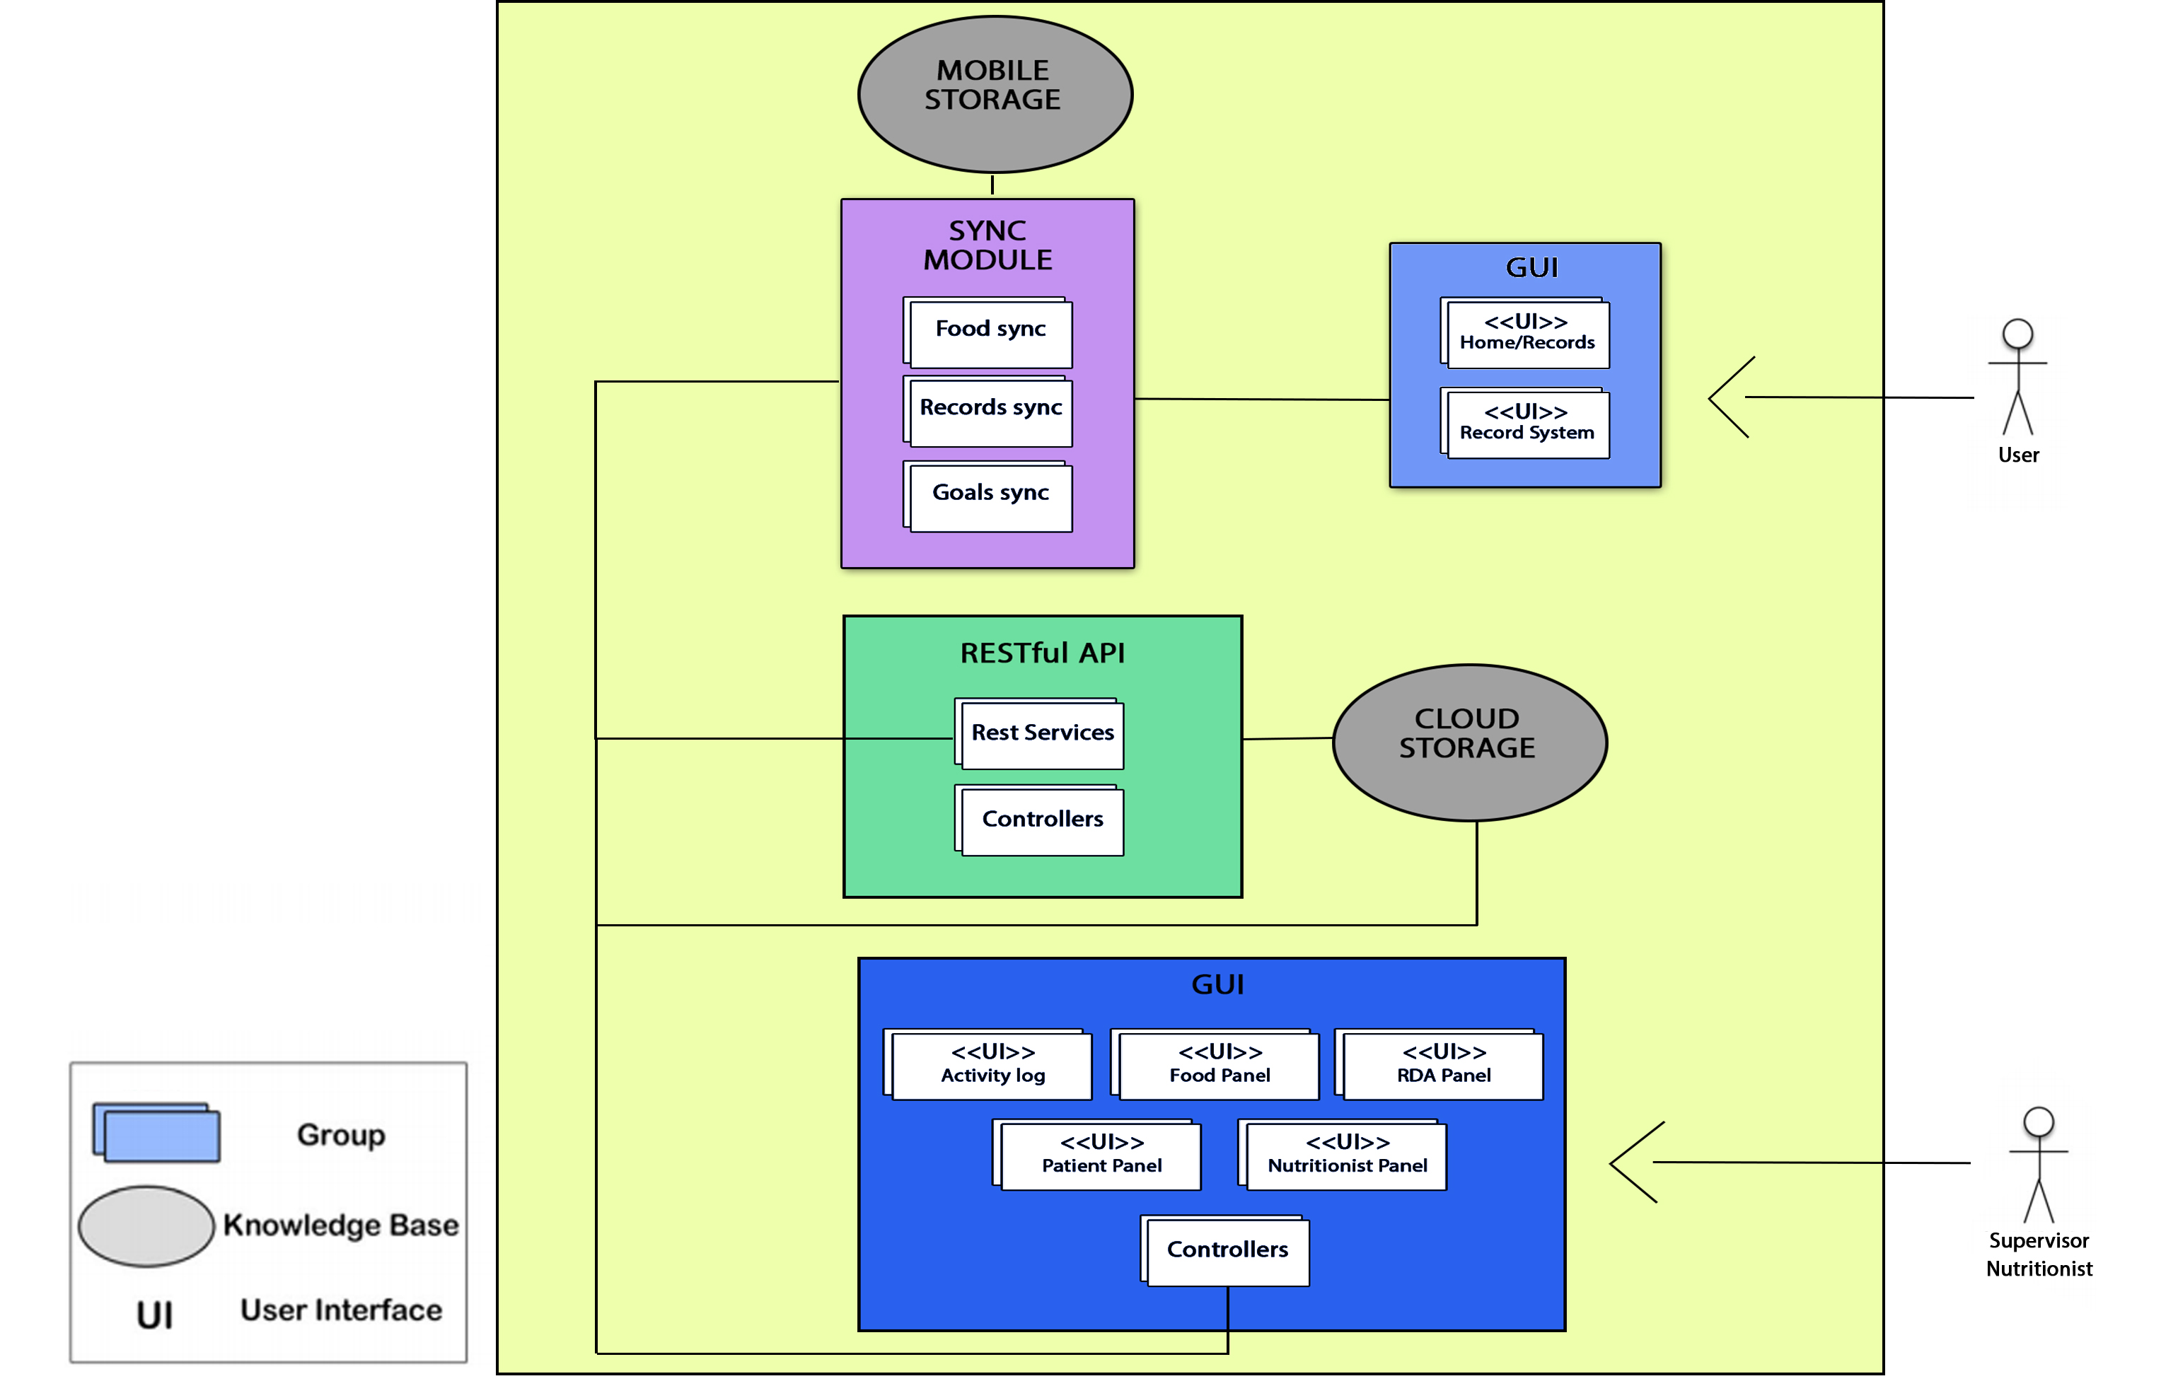

**Figure 1.** Architecture scheme of the system.

These three parts (mobile platform, nutritionist platform and cloud platform with the API RESTfull) compose the architecture of the):

The cloud and the API RESTful (*API RESTful*), connect all the parts of the architecture which synchronizes the records of each user, downloading and uploading the data of the mobile applications of the monitored users (*Sync module*) automatically following a system of verification of the record creation dates, keeping the newer versions on the cloud server (*Cloud database through the API RESTful*). The mobile application used by users registers offline in a database, and periodically synchronizes the new nutritional records with the cloud server through secure requests (*Sync module*), updating the new records on the server, being accessible by the nutritionist through the web administration panel (*Nutritionist GUI*).

The synchronization module (*Sync module*) acts as a bridge between the database of the mobile application and the cloud server, synchronizing the different data of the application (food registers, food and goals). Additionally, during this synchronization, the new nutritional goals established by the nutritionists will be downloaded for a specific date.

The graphic user interfaces (*GUI*) are responsible for showing the data to users and nutritionists, isolating the transformation and adaptation of the data. The UIs of the user’s mobile application and all the screens of the nutritionist’s panel are included in this component. This makes Food4Living highly customizable as it allows a wide variety of user and expert applications with different UIs.

This is achieved with the highly modular architecture proposed. The *RESTful API* module is responsible for providing the services and resources of the cloud storage for external requests, authenticating the requests with security tokens, while the controllers of the modules are responsible for adapting the information extracted from the databases or requests to execute the responses to the requests or to fill in the views of the user interfaces (*GUI*).

The scheme communication system is summarized in Figure 2. The mobile platform will update (download) the available foods, the food registration bases and the food goals whenever there is a new version of this information on the cloud server. In the same way, the data of the food registers of the users will be uploaded or updated in the cloud server whenever new records are introduced through the mobile platform.

The web platform will make use of all the data of the system and will manage the food data (e.g., Goals, Users, RDA Tables, etc.) introducing new information through the chosen administration panel. It will also consult the server for said information and establish food goals for each user, updating the appropriate data of the cloud server.

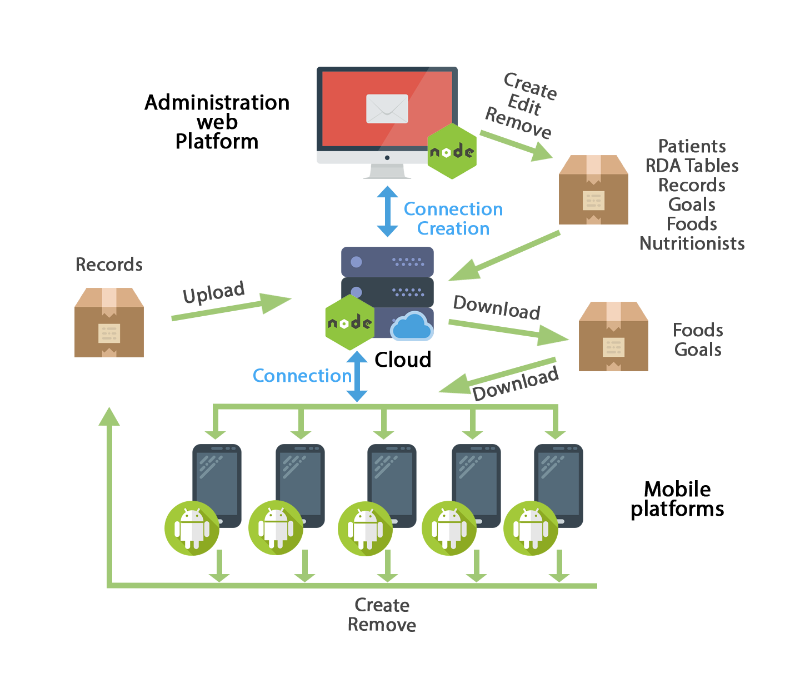

**Figure 2.** Communication scheme of the system.

4. Food4Living: Cloud-based mobile platform to monitoring dietary habits

Food4Living is a platform aimed at encouraging healthy habits and maintaining a diet supervised by nutrition professionals through a telemonitoring system. It is the core technology for nutritional coaching within the Avisame Spanish Research Plan and a European COST action, and it is integrated within a more complex system that includes virtual advisors based on graphic avatars and other aspects of healthy life, such as locomotion, postural ergonomics and physical exercise.

Food4Living has two main groups of users (besides the technical system administrator): 1) monitored *users,* who employ a mobile application, and 2) monitoring *professionals* (nutritionists and dieticians) that analyze the relevant data of the monitored users, comparing them with objective references (Figure 3).

The monitored user (hereinafter *user*) uses the mobile application to track food records, reflecting their eating habits. This application synchronizes, automatically, the user's data and receive the indications and meal plans of the nutritionists, who supervise the user. In addition, the monitored user receives notifications and reminders to carry out a complete meal plan. On the other hand, the supervisor nutritionist (hereinafter *supervisor)*, uses a panel to collect relevant pieces of data, in order to creates food plans and nutritional goals adapted to their particular needs and eating habits of the user. Everything is synchronized through a cloud computing approach, which will be describe in the next section.

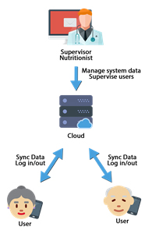

**Figure 3**. Platform overview.

To build and app in Food4Living, the developers must develop and implement only the views (GUI) and consume the services provided by the RESTful API [22,23] to obtain the data. As it has been mentioned, for the realization of the *web platform*, we have made a design according to the Model-view-controller pattern, making a controller for each important block of requests, such as food management, users, nutritionists, and

Recommended daily allowance tables. These controllers make use of the REST API to request the necessary data from the database, performing an authentication from a token according to Jason Web Token (JWT) [24]. Depending on the type of privileges of the user, some or other data will be displayed. This *API* works as a wrapper between the system information (storage) and third-party applications, offering different types of data according to the routes that are executed in the different services it manages.

The API is divided into services, which will be the controllers responsible for offering the data processed abroad, differentiating and restricting which requests are available without authentication and which require a valid token. While supervised users will have access to their plans and the possibility to update their tracking, nutritionists will be able to:

* Register in the system the new users who will be supervised.
* Create and manage the available foods throughout the system and their nutritional information.
* Manage their own tables of recommended daily allowance.
* Consult and edit the food registries of users under their supervision.
* Establish and update goals and nutritional plans based on the statistics obtained with their eating habits.

Two of the most important services are of the API are the *Objective Service* and the *FoodRegister Service* that are in charge of synchronizing the food records of each user with the mobile application and the administration panel of the web platform following a mechanism that will be explained later. The rest of the services of the API are in charge of serving the information to the rest of the modules of the system and to external calls. Also statistics of food intake can be generated in real time and it is possible to generate comparisons, reports and calendars. With respect to data management, the main system data is sent and received through requests to the API, receiving and responding information represented in JSON [25]. To secure sensitive system data, responses have been encrypted using JWT tokens, giving access to certain parts of the API only if the request is made with a valid access token. All other routes and requests without sensitive data are available through HTTP requests to the API, and receive responses in JSON format.

4.1. Key platform features

The architecture proposed leverages several key features that we would like to highlight:

* Dynamic data and system adaptability, allowing the incorporation of new foods with non-limited nutritional information. These foods are formed by different attributes equivalent to the nutrients that form them, having only the fields associated with these data and not replicating in empty fields information that they don't have. From which different nutritional statistics can be made depending on the nutritional formats of the food in the patients' food records. Representing the food data of each food from XML to interpret the different fields of each food.
* System based on nutritional goals. These goals are the main communication mechanism between nutritionists and supervised users. With the goals the nutritionists establish guidelines and diets adapted to each user. The goals are displayed directly on the mobile platform and are automatically updated at the time the food established by the nutritionist is ingested, being completed when the amount indicated by the professional is reached.
* System data synchronization, in the case of the mobile platform, it will synchronize the food from the cloud when the date of modification of any of the foods is newer than the one stored in its internal database. In the case of the goals, it will download the information of these when it has something new, that is to say, when a new goal has been introduced in the system and hasn't synchronized yet. Finally, in the case of food records, those records that do not exist in the local database will be downloaded when a record with a modification date / creation with a more recent date appears in the cloud, and in the same way, if the application mobile detects that the cloud has an earlier version than its database will upload all new records.
* Multi-user, representing different profiles for administrators, nutritionists, patients and their caregivers. Each profile has permissions and privileges with which to perform one role or another in the system.
* Accessible for different user profiles. Specially designed to reduce the number of interactions during the use of the mobile application.
* Interoperable system, communicating in real time the information between the three different modules of the platform, 1) the user’s mobile app ,2) the web platform for nutritionist and 3) the RESTful API.
* Immediate availability, disposal of use in any environment with or without internet connection, registering the data in local databases and making synchronizations possible.

4. Food4Living Applications

One of the benefits of the Food4Living platform is the possibility to deploy new applications implemented by developers/programmers. As explained previously, we provide an API with well-defined interfaces to enable communication between all parts of the system (API REST). During the design of the API, data format and representation issues have also been considered, as well as the use of standard (JSON) technologies to facilitate their extensibility, maintenance and interoperability with third party applications and systems.

The following applications have been developed, supported by Food4Living Platform:

* A mobile application A mobile application aimed at supervised users, with which to record their nutritional habits.
* A web application for the nutritionists to manage and supervise the users in their charge.

**4.1. Web platform**

Through the web platform, nutritionists register, consult, evaluate and establish nutritional guidelines and personalized plans for each user under their supervision. To do this, the system orchestrates its different modules by mean of the architecture proposed and inserts, processes and delivers dynamic data of the users supervised. The system has been designed to interpret different data formats, making it scalable and able to adapt to the new way of representing the data. This way, it is possible to add new parameters in the food, statistics and all parts of the system without affecting its structure. The web interface is based on HTML5 and Materialize CSS, and presents the following functionalities:

* **System of authentication and recognition of different users:** Through the credentials introduced into the system, nutritionists will be able to access the web system through a login form, where the user type is automatically recognized; that is, user administrator, or nutritionist.
* **General administration panel:** Through the general panel will access all the functionalities of the system.
* **User panel:** Panel showing the list of users associated with the nutritionist, showing the main data of the people monitored, and the options to add, display, edit and eliminate such users.
* **User's personal calendar:** Calendar where the supervised users' food records and goals are displayed (Figure 4). The nutritionist will be able to interact with clicks, eliminating or adding new ones to the desired date. This calendar is the main tool of communication with the supervised users, with it the nutritionists can observe the daily progress, breaking down the intakes into the different hours of the day and observing a summary of its nutritional composition. The nutritionist can interact with the calendar by clicking on the different days, establishing new records or goals that will be visible to users from the mobile application. It is also possible to interact with the goals or records already inserted to obtain more details or to remove them from the patient's calendar. Nutritional goals are diet mechanisms where nutritionists associate a target food to eat, a certain amount and a deadline to achieve that goal. The goals are updating their progress according to the food records of the monitored user. It is possible to enter daily goals or goals with a certain duration. With this mechanism, nutritionists can create specific diets by setting a specific time for each food of the goal, for example, establishing a food goal of drinking a glass of milk at breakfast and establishing the specific day for that goal, continuing with another food for lunch, etc.

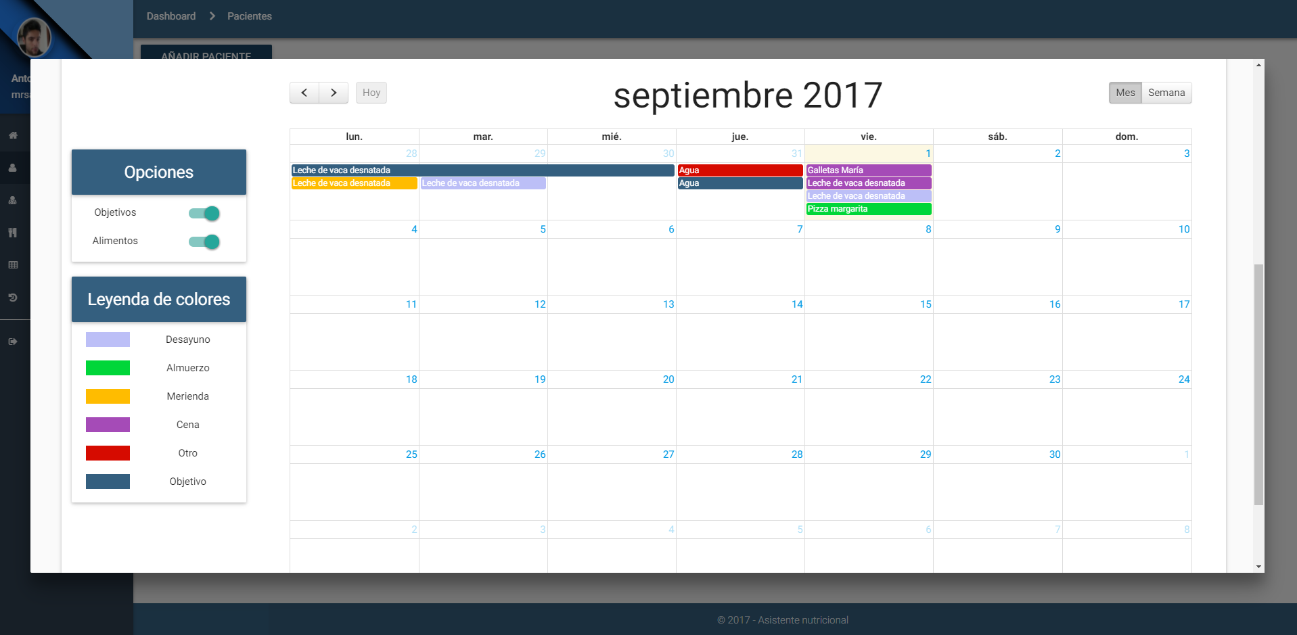

**Figure 4.** User's personal calendar.

* **User statistics:** Section where to generate a statistical report of the supervised user from the records recorded in the selected month, comparing these results with a table of RDA (daily recommended allowance) registered by that nutritionist and previously selected and where to observe a weekly summary disaggregated in timetables for the main macronutrients.
* **Nutritionist’s panel:** This is the management panel for the system administrator to add, edit or remove nutritionist users.
* **Food management:** Panel that allows the creation, modification and elimination of new foods in the system. Such foods will be used by the mobile application and the patient's personal calendar for the incorporation of new food records or goals. It should be noted that this section indicates the elements necessary for food registration; that is, the photographs to be used in the mobile application, their correspondence in portions, and all the nutritional information of the food. The quantity selection system developed is based on choosing quantities from photographs that visually represent the portion size, and transparently each photograph would correspond to a size. For example: If we drink skimmed cow's milk, we can take a small cup, a medium cup or a bowl of large milk, where each container corresponds to a different portion. For example, a small cup a portion of 100g, to the glass a portion of 200g and to the bowl one of 350g translating this to: cup = 1.0, cup = 2.0 and bowl = 3.5; since multiplying these portions by their correspondence would yield the equivalent of 100g, 200g and 350g. That is why one of the indispensable requirements is to correctly choose the equivalent photographs for the portions.
* **Management of daily-recommended allowance (RDA) tables:** Panel for the creation, modification and elimination of tables of information to make the statistical comparisons of the people monitored and to generate the reports already described above.

**4.2. Mobile platform**

The main tool of monitored users is an Android based mobile application, which monitors their eating habits, noting the food intake throughout the day, introducing a new record in their mobile application, and synchronizing in a transparent way the data, so that almost in real time, the supervisors can keep track of the user. Through a simple interface, users can record the food ingested using a simple form where with three steps they select the schedule of intake, food and quantity taken. For this, we have implemented a quantity selection system of images that show representations of different portions for the same food, for example; annotating a specific beverage, displaying images with different sizes, making the user choose the photograph that most resembles the portion ingested. This system module has the following functionalities:

* **Secure authentication:** Authentication protected by a generated token that only allows the connection to be opened from a point, thus making it unreachable.
* **Welcome screen and display of objectives:** An initial screen that welcomes greeting depending on the schedule. At the same time, it shows more interesting information, such as today's pending goals (diet plan system), indicating that it should be taken and which portion size. This screen also shows the main buttons of the application, the simplification of actions to return to the home panel, add a new record, or view the annotated records. Attending the usability needs of the elderly, the interface has been simplified enough to show only the most essential elements. The "*Objetivos*:" panel shows the user's daily goals that have not been exceeded. (Figure 5).

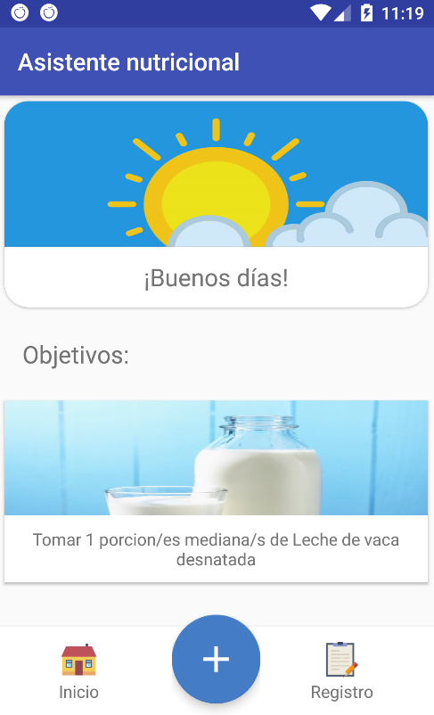

**Figure 5.** Welcome screen and display of outstanding goals.

* **Records system:** Food selection screen that suggests foods obtained from the local database of the application (Figure 6 (b)). Then, a quantity selection screen (Figure 6 (c)) is showed using the method described above (Figure 6 and 7).

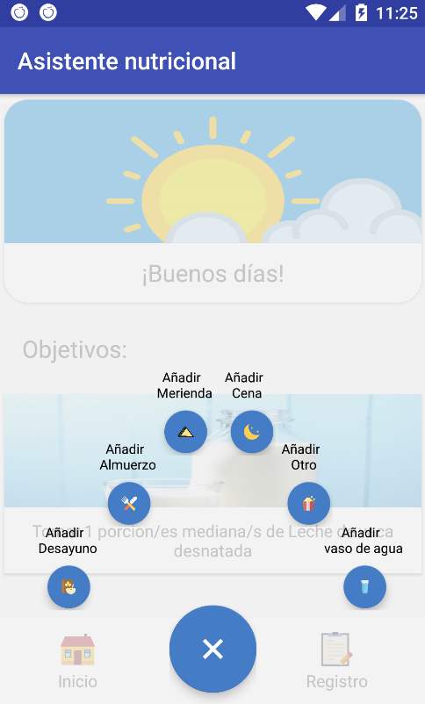 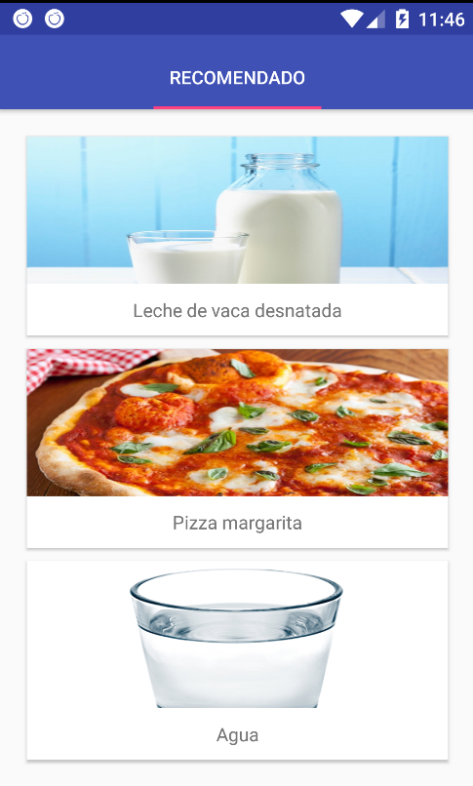 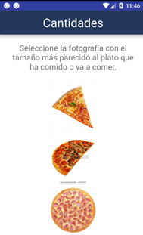

|  |  |  |
| --- | --- | --- |
| (**a**) | (**b**) | (c) |

**Figure 6.** Drop down to register a meal.

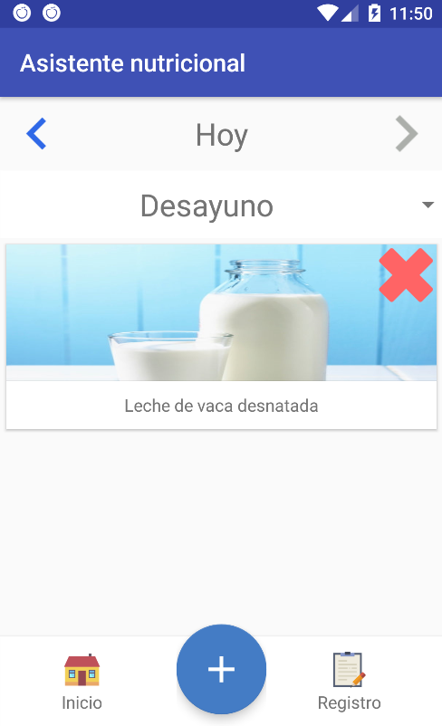

**Figure 7.** Record display panel.

* **Notification reminder system:** When aging, people gradually loose the feeling of thirst, so one of the most important functionalities of our solution is to remind users to consume liquids and meals in the necessary periods. Through the notification system of mobile devices, the application launches reminders to drink water on a regular basis, and from preset hours reminds the user if he has to write down a meal in the application (Figure 8). To do this, different services are used that execute inscriptions in the system of alarms of the operating system in the background, executing a service for each schedule of annotations.

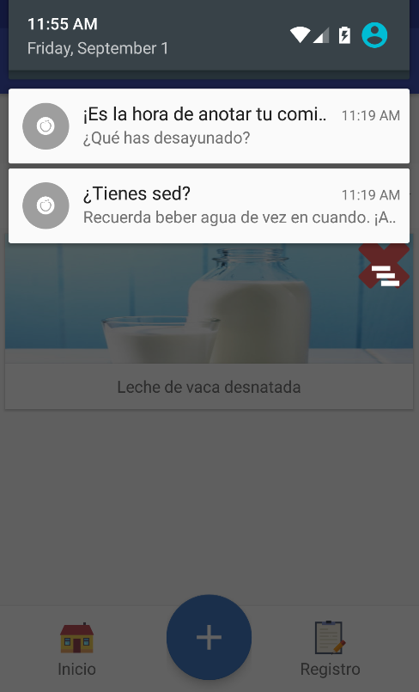

**Figure 8.** Notification reminder system.

4. Conclusions and future work

Telemonitoring is a relevant alternative to promote healthy eating habits, especially for elderly. However, the software systems available in the literature lack the adaptability and expert supervision demanded by this population. For this reason, we have proposed Food4Living, a multiplatform scheme with which to develop applications that satisfy the perspectives of users and professional nutritionists. With it, we try to facilitate the development of the necessary basic questions of a nutritional telemonitoring system composed of three interconnected subsystems (Administration platform, server platform and mobile platform). These three components aim to solve problems not addressed by the applications and models that currently exist. Developing a platform aimed to 1) users, with which they will offer the data of the system about their behaviors and eating habits, and will collect plans, guidelines, diets and advice from a professional nutritionist; and 2) nutritionists, with whom they will analyze all the data on the users, and where they will establish nutritional action plans adapted to each user.

At the same time, we present Food4LivingAPP, an implementation of the proposed platform as a software application. With this implementation we show how the different subsystems of the proposed model can be integrated, offering as a final result a fully usable application that meets the needs of our initial objective.

Likewise, Food4LivingAPP has been carried out, integrating the work in an open project, the web platform, the mobile and the server in the cloud, satisfying the needs of each party and interoperating among all the platforms to build a system that allows semi-autonomous monitoring It forms the nutritional habits of each user, but at the same time, it shows in real time the progress of each user giving him the opportunity to develop action plans and diets adapted to each individual, promoting in a simple and not abrupt way a progressive change to good and healthy habits.

Currently, we are undergoing the evaluation of the app within the Avisame project with elderly users and professional nutritionists.

For the next phases of our project, pilot studies will be started to test the usability of the platform and its perceived usefulness, new mechanisms of artificial intelligence will be introduced in order to suggest adapted diets according to the most ingested foods of the users. We will apply automatic data mining mechanisms based on user statistics, adapting the project to the results and bringing the final product closer to users and researchers.

References

1. Eileen T Kennedy, A. J. (2006). Evidence for nutritional benefits in prolonging wellness.
2. World Health Organization (WHO). (October de 2017). Obesity and overweith Fact Sheet). Retrieved from WHO: http://www.who.int/mediacentre/factsheets/fs311/en/
3. Palzer, S. (2009). Food structures for nutrition, health and wellness. Trends in Food Science & Technology, 20(5), 194-200.
4. Gell, N. M., Rosenberg, D. E., Demiris, G., LaCroix, A. Z., & Patel, K. V. (2013). Patterns of technology use among older adults with and without disabilities. The Gerontologist, 55(3), 412-421., 3rd ed.; Publisher: Publisher Location, Country, 2008; pp. 154–196, ISBN.
5. Osborne, D. R., & Voogt, P. I. (1978). The analysis of nutrients in foods. Academic Press Inc.(London), Wardle, J., Parmenter, K., & Waller, J. (2000). Nutrition knowledge and food intake. Appetite, 34(3), 269-275.
6. James H. Swan, Jennifer J. Severance, Keith Turner. (2016) Senior Centers and Nutritional Outcomes: A Texas Example. Social Work in Public Health 31:5, pages 439-452
7. Amanda K. Sylvie, Qianzhi Jiang, Nancy Cohen. (2013) Identification of Environmental Supports for Healthy Eating in Older Adults. Journal of Nutrition in Gerontology and Geriatrics 32:2, pages 161-174.
8. Ventola, C. L. (2014). Mobile devices and apps for health care professionals: uses and benefits. Pharmacy and Therapeutics, 39(5), 356.
9. Wang, Q., Egelandsdal, B., Amdam, G. V., Almli, V. L., & Oostindjer, M. (2016). Diet and physical activity apps: perceived effectiveness by app users. JMIR mHealth and uHealth, 4(2).
10. Stumm, G., Blaik, A., Kropf, S., Westphal, S., Hantke, T. K., & Luley, C. (2016). Long-Term Follow-Up of the Telemonitoring Weight-Reduction Program “Active Body Control”. Journal of diabetes research, 2016.
11. Chen, J., Gemming, L., Hanning, R., & Allman-Farinelli, M. (2017). Smartphone apps and the nutrition care process: current perspectives and future considerations. Patient Education and Counseling.
12. Villarreal, V., Fontecha, J., Hervas, R., & Bravo, J. (2014). Mobile and ubiquitous architecture for the medical control of chronic diseases through the use of intelligent devices: Using the architecture for patients with diabetes. Future generation computer systems, 34, 161-175.
13. Triboan, D., Chen, L., & Chen, F. (2016, March). Towards a mobile assistive system using service-oriented architecture. In Service-Oriented System Engineering (SOSE), 2016 IEEE Symposium on (pp. 187-196). IEEE.
14. Kyriazakos, S., Valentini, V., Cesario, A., & Zachariae, R. (2017). FORECAST-a cloud-based personalized intelligent virtual coaching platform for the well-being of cancer patients. Clinical and Translational Radiation Oncology.
15. Luley, C., Blaik, A., Götz, A., Kicherer, F., Kropf, S., Isermann, B., ... & Westphal, S. (2014). Weight loss by telemonitoring of nutrition and physical activity in patients with metabolic syndrome for 1 year. Journal of the American College of Nutrition, 33(5), 363-374.
16. Armour, U. (2017). MyFitnessPal. Retrieved from https://www.myfitnesspal.com/es
17. AB, L. (2017). *Lifesum* . . Retrieved from https://lifesum.com/
18. Ediger. (2017). Diary of Nutrition. Retrieved from https://play.google.com/store/apps/details?id=ediger.diarynutrition
19. Freeletics. (2017). Freeletics Nutrition. Retrieved from https://www.freeletics.com/es/nutrition
20. 8fit. (2017). 8fit. Retrieved from https://goo.gl/tdcNYb
21. Deacon, J. (2009). Model-view-controller (mvc) architecture. Online] [ Aforementioned: 10 de march 2006.] http://www. jdl. co. uk/briefings/MVC. pdf.
22. Feng, X., Shen, J., & Fan, Y. (2009, October). REST: An alternative to RPC for Web services architecture. In Future Information Networks, 2009. ICFIN 2009. First International Conference on (pp. 7-10). IEEE.
23. Fielding, R. T., & Taylor, R. N. (2000). Architectural styles and the design of network-based software architectures (p. 151). Doctoral dissertation: University of California, Irvine.
24. Auth0. (2017). JSON Web Tokens. Obtained from https://jwt.io/
25. Crockford, D. (2006). The application/json media type for javascript object notation (json).
26. Fielding, R. (2000). Representational state transfer. Architectural Styles and the Design of Netowork-based Software Architecture, 76-85

H:\documents\layout\new template June 2014\figures\CC-BY logo original v1.wmf© 2017 by the authors. Submitted for possible open access publication under the   
terms and conditions of the Creative Commons Attribution (CC BY) license (<http://creativecommons.org/licenses/by/4.0/>).